

MCM3000 Direct Serial Communication

Baud Rate = 9600

Address = 1

Conversion factors are for units in nm.

**LNR:** 39.0625

**PLS:** 211.6667

**AScope Z:** 1.0

**BScope:** 500.0

**BScope Z:** 100.0

**Objective Mover:** 1.0

**Commands:**

**Set Encoder Counter Command**

This message is used to set the encoder count in the controller

Command structure (12 bytes):



|  |  |  |
| --- | --- | --- |
| **Field** | **Description** | **Format** |
| Chan Ident | The channel being addressed | word |
| Encoder count | The new value of the encoder counter as a 32-bit signed integer, encoded in the Intel format. The scaling between real | long |

Example: Set the encoder counter for Axis 2 (stage3) to 0 counts

TX 09, 04, 06, 00, 00, 00, 02, 00, 00, 00, 00, 00

*Position*: 00, 00, 00, 00 (0 counts)

**Stop Command**

This command stops any type of motor move on the specified channel.

Command structure (6 bytes):

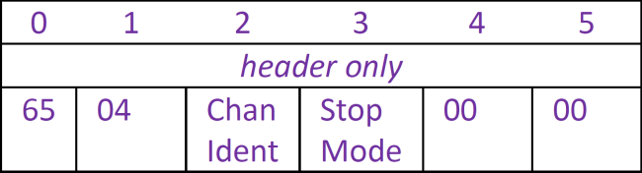

|  |  |  |
| --- | --- | --- |
| **Field** | **Description** | **Format** |
| Chan Ident | The channel being addressed | word |
| Stop Mode | The stop mode defines either an immediate (abrupt) or profiles tops. Set this byte to 0x01 to stop immediately, or to 0x02 to stop in a controller (profiled) manner. | word |

Example: Stop immediately Axis 0 (stage1)

TX 65, 04, 02, 01, 00, 00

**Query Position**

Command structure (6 bytes):

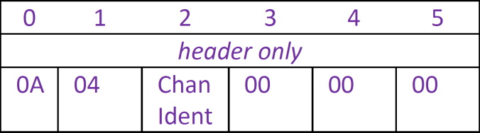

|  |  |  |
| --- | --- | --- |
| **Field** | **Description** | **Format** |
| Chan Ident | The channel being addressed | word |

Response structure (12 bytes)

6 byte header followed by 6 byte data packet as follows: 

|  |  |  |
| --- | --- | --- |
| **Field** | **Description** | **Format** |
| Chan Ident | The channel being addressed | word |
| Encoder count | The new value of the encoder counter as a 32-bit signed integer, encoded in the Intel format. The scaling between real | long |

**Go to Position Command**

Command structure (12 bytes):



|  |  |  |
| --- | --- | --- |
| **Field** | **Description** | **Format** |
| Chan Ident | The channel being addressed | word |
| Absolut Distance | The distance to move. This is a 4 byte signed integer that specifies the absolute distance in position encoder counts. | long |

**Query Motor Status (busy or ready)**

Command structure (6 bytes):

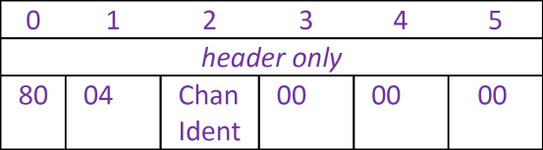

|  |  |  |
| --- | --- | --- |
| **Field** | **Description** | **Format** |
| Chan Ident | The channel being addressed | word |

Response:

Busy: true == (Byte 16) & 0x30

Axis is set to No Motor: true == (Byte 17) & 0x01